7.3.6 Editors - 3D View - Sidebar - Tool Tab - Mesh - Sculpt Mode
Detailed table of content 4
Tools Tab in Sculpt Mode 11
Brushes Panel 11
Custom Icon 11
Brush Settings Panel 12
Brush Settings Panel - Common Settings 12
Radius 12
Radius Unit 13
Strength 13
Normal Radius 13
Hardness 13
Autosmooth 13
Brush Settings Panel - Draw brush 14
Direction Add / Subtract 14
Brush Settings Panel - Draw Sharp brush 14
Direction Add / Subtract 14
Brush Settings Panel - Clay brush 14
Direction Add / Subtract 14
Plane Offset 15
Brush Settings Panel - Clay Strip brush 15
Direction Add / Subtract 15
Plane Offset 15
Plane Trim 15
Tip roundness 15
Brush Settings Panel - Clay Thumb brush 16
Direction Add / Subtract 16
Plane Offset 16
Plane Trim 16
Brush Settings Panel - Layer brush 16
Direction Add / Subtract 17
Height 17
Persistent 17
Brush Settings Panel - Inflate brush 17
Direction Inflate / Deflate 17
Brush Settings Panel - Blob brush 17
Magnify 18
Brush Settings Panel - Crease brush 18
Direction Add / Subtract 18
Pinch 18
Brush Settings Panel - Smooth brush 18
Direction Smooth / Enhance 18
Brush Settings Panel - Flatten brush 19
Direction Contrast / Flatten 19
Plane Offset 19
Plane Trim 19
Brush Settings Panel - Fill brush 19
Direction Fill / Deepen 19
Plane Offset 20
Plane Trim 20
Area Radius 20
Invert to Scrape 20
Brush Settings Panel - Fill brush 20
Direction Scrape / Peaks 20
Plane Offset 20
Plane Trim 21
Area Radius 21
Invert to Fill 21
Brush Settings Panel - Multi-plane Scrape brush 21
Direction Scrape / Peaks 21
Plane Angle 21
Dynamic Mode 21
Show Cursor Preview 21
Brush Settings Panel - Pinch brush 22
Direction Magnify / Pinch 22
Autosmooth 22
Brush Settings Panel - Grab brush 22
Direction Magnify / Pinch 22
Normal Weight 22
Grab active Vertex 22
Brush Settings Panel - Elastic Deform brush 23
Normal Weight 23
Deformation 23
Volume Preservation 23
Brush Settings Panel - Snake Hook brush 23
Normal Weight 23
Magnify 24
Rake 24
Brush Settings Panel - Thumb brush 24
Brush Settings Panel - Pose brush 24
Deformation Target 24
Deformation 24
Rotation Origins 24
Pose Origin Offset 25
Smooth Iterations 25
Pose IK Segments 25
Keep Anchor Point 25
Connected only 25
Max Element Dinstance 25
Brush Settings Panel - Nudge brush 25
Brush Settings Panel - Rotate brush 25
Brush Settings Panel - Slide Relax brush 26
Deformation 26
Brush Settings Panel - Boundary brush 26
Deformation Target 26
Deformation 26
Boundary Falloff 26
Boundary Origin Offset 27
Brush Settings Panel - Cloth brush 27
Persistent 27
Simulation Area 27
Deformation 28
Force Falloff 28
Cloth Mass 28
Cloth Damping 28
Soft Body Influence 28
Enable Collision 28
Brush Settings Panel - Simplify brush 28
Brush Settings Panel - Mask brush 29
Direction Add / Subtract 29
Mask Tool 29
Brush Settings Panel - Multires Displacement Eraser brush 29
Brush Settings Panel - Draw Face Sets brush 29
Brush Settings Panel - Advanced Subpanel 30
Topology Automasking 30
Face Sets Auto-masking 30
Accumulate 30
Sculpt Plane 30
Original Normal 30
Original Plane 30
Front Faces Only 30
Brush Settings Panel - Texture Subpanel 31
Brush Settings Panel - Stroke Subpanel 37
Stroke Panel with Stroke method Space 37
Stroke Panel with Stroke method Curve 39
Stroke Panel with Stroke method Line 40
Stroke Panel with Stroke method Airbrush 42
Stroke Panel with Stroke method Anchored 43
Stroke Panel with Stroke method Drag dot 43
Stroke Panel with Stroke method dot 44
Brush Settings Panel - Falloff Subpanel 45
Selecting Points 45
Adding Points 46
Navigation elements 46
Brush Settings Panel - Cursor Subpanel 47
Cursor checkbox in header 47
Cursor Color 47
Inverse Cursor Color 47
Falloff Opacity 47
Texture Opacity 47
Dyntopo Panel 48
Dyntopo Panel 48
Remesh Panel 49
Voxel Size 50
Adaptivity 50
Fix Poles 50
Smooth Normals 50
Preserve 50
Remesh 50
Symmetry Panel 51
Mirror 51
Lock 51
Tiling 51
Feather 51
Radial 51
Tile Offset 52
Direction 52
Symmetrize 52
Sculpt Mode - Options Panel 52
Display 52
Auto Masking 52
Gravity subpanel 53

Detailed table of content

Detailed table of content
Detailed table of content 4
Tools Tab in Sculpt Mode 11
Brushes Panel 11
Browse Brush 11
Custom Icon 11
Brush Settings Panel 12
Brush Settings Panel - Common Settings 12
Radius 12
Size Pressure 12
Use Unified Radius 13
Radius Unit 13
Strength 13
Size Pressure 13
Use Unified Radius 13
Normal Radius 13
Hardness 13
Invert Pressure for Hardness 13
Use pressure for hardness 13
Autosmooth 13
Use pressure for hardness 13
Brush Settings Panel - Draw brush 14
Direction Add / Subtract 14
Brush Settings Panel - Draw Sharp brush 14
Direction Add / Subtract 14
Brush Settings Panel - Clay brush 14
Direction Add / Subtract 14
Plane Offset 15
Brush Settings Panel - Clay Strip brush 15
Direction Add / Subtract 15
Plane Offset 15
Plane Trim 15
Distance 15
Tip roundness 15
Brush Settings Panel - Clay Thumb brush 16
Direction Add / Subtract 16
Plane Offset 16
Plane Trim 16
Distance 16
Brush Settings Panel - Layer brush 16
Direction Add / Subtract 17
Height 17
Persistent 17
Set Persistent Base 17
Brush Settings Panel - Inflate brush 17
Direction Inflate / Deflate 17
Brush Settings Panel - Blob brush 17
Direction Add / Subtract 17
Magnify 18
Brush Settings Panel - Crease brush 18
Direction Add / Subtract 18
Pinch 18
Brush Settings Panel - Smooth brush 18
Direction Smooth / Enhance 18
Brush Settings Panel - Flatten brush 19
Direction Contrast / Flatten 19
Plane Offset 19
Plane Trim 19
Brush Settings Panel - Fill brush 19
Direction Fill / Deepen 19
Plane Offset 20
Plane Trim 20
Area Radius 20
Invert to Scrape 20
Brush Settings Panel - Fill brush 20
Direction Scrape / Peaks 20
Plane Offset 20
Plane Trim 21
Area Radius 21
Invert to Fill 21
Brush Settings Panel - Multi-plane Scrape brush 21
Direction Scrape / Peaks 21
Plane Angle 21
Dynamic Mode 21
Show Cursor Preview 21
Brush Settings Panel - Pinch brush 22
Direction Magnify / Pinch 22
Autosmooth 22
Brush Settings Panel - Grab brush 22
Direction Magnify / Pinch 22
Normal Weight 22
Grab active Vertex 22
Brush Settings Panel - Elastic Deform brush 23
Direction Magnify / Pinch 23
Normal Weight 23
Deformation 23
Volume Preservation 23
Brush Settings Panel - Snake Hook brush 23
Normal Weight 23
Magnify 24
Rake 24
Brush Settings Panel - Thumb brush 24
Brush Settings Panel - Pose brush 24
Deformation Target 24
Deformation 24
Lock Rotation when scaling 24
Rotation Origins 24
Pose Origin Offset 25
Smooth Iterations 25
Pose IK Segments 25
Keep Anchor Point 25
Connected only 25
Max Element Dinstance 25
Brush Settings Panel - Nudge brush 25
Brush Settings Panel - Rotate brush 25
Brush Settings Panel - Slide Relax brush 26
Deformation 26
Brush Settings Panel - Boundary brush 26
Deformation Target 26
Deformation 26
Boundary Falloff 26
Boundary Origin Offset 27
Brush Settings Panel - Cloth brush 27
Persistent 27
Set Persistent Base 27
Simulation Area 27
Simulation Limit 27
Simulation Falloff 27
Pin Simulation Boundary 27
Deformation 28
Force Falloff 28
Cloth Mass 28
Cloth Damping 28
Soft Body Influence 28
Enable Collision 28
Brush Settings Panel - Simplify brush 28
Brush Settings Panel - Mask brush 29
Direction Add / Subtract 29
Mask Tool 29
Brush Settings Panel - Multires Displacement Eraser brush 29
Brush Settings Panel - Draw Face Sets brush 29
Brush Settings Panel - Advanced Subpanel 30
Topology Automasking 30
Face Sets Auto-masking 30
Accumulate 30
Sculpt Plane 30
Original Normal 30
Original Plane 30
Front Faces Only 30
Brush Settings Panel - Texture Subpanel 31
Browse Texture to be linked 31
Adding a texture 31
Texture Edit box 32
Brush Mapping 32
Brush Mapping with mapping method View Plane and Area Plane 32
Angle edit box 33
Rake 33
Random 33
Random edit box 33
Offset 33
Size 33
Sample Bias 33
Brush Mapping with mapping method Tiled 34
Angle edit box 34
Offset 34
Size 34
Sample Bias 34
Brush Mapping with mapping method 3D 34
Offset 35
Size 35
Sample Bias 35
Brush Mapping with mapping method Random 35
Angle edit box 35
Rake 35
Random 36
Random edit box 36
Offset 36
Size 36
Sample Bias 36
Brush Mapping with mapping method Stencil 36
Image Aspect 36
Angle edit box 36
Offset 37
Stencil Texture Controls 37
Brush Settings Panel - Stroke Subpanel 37
Stroke Panel with Stroke method Space 37
Spacing Edit Box 37
Spacing Pressure 37
Spacing Distance 38
Adjust Strength for Spacing 38
Dash Ratio 38
Dash Length 38
Jitter Edit Box 38
Jitter Pressure 38
Jitter Unit 38
Input Samples Edit Box 38
Stabilize Stroke 38
Smooth Stroke Radius Edit Box 38
Smooth Stroke Factor Edit Box 38
Stroke Panel with Stroke method Curve 39
Spacing Edit Box 39
Spacing Distance 39
Adjust Strength for Spacing 39
Paint Curve edit box 40
Draw Curve Button 40
Jitter Edit Box 40
Jitter Pressure 40
Jitter Unit 40
Input Samples Edit Box 40
Stroke Panel with Stroke method Line 40
Spacing Edit Box 41
Spacing Distance 41
Adjust Strength for Spacing 41
Jitter Edit Box 41
Jitter Pressure 41
Jitter Unit 41
Input Samples Edit Box 41
Stroke Panel with Stroke method Airbrush 42
Rate Edit Box 42
Spacing Distance 42
Jitter Edit Box 42
Jitter Pressure 42
Jitter Unit 42
Input Samples Edit Box 42
Stabilize Stroke 42
Smooth Stroke Radius Edit Box 43
Smooth Stroke Factor Edit Box 43
Stroke Panel with Stroke method Anchored 43
Edge to Edge 43
Spacing Distance 43
Input Samples Edit Box 43
Stroke Panel with Stroke method Drag dot 43
Spacing Distance 43
Input Samples Edit Box 44
Stroke Panel with Stroke method dot 44
Spacing Distance 44
Jitter Edit Box 44
Jitter Unit 45
Input Samples Edit Box 45
Stabilize Stroke 45
Smooth Stroke Radius Edit Box 45
Smooth Stroke Factor Edit Box 45
Brush Settings Panel - Falloff Subpanel 45
Selecting Points 45
Adding Points 46
Navigation elements 46
Zoom in and out 46
Tools 46
Reset View 46
Vector Handle 46
Auto Handle 46
Auto Clamped Handle 46
Reset Curve 46
Use Clipping 46
Delete Points 46
Curve Presets 47
Falloff Shape 47
Brush Settings Panel - Cursor Subpanel 47
Cursor checkbox in header 47
Cursor Color 47
Inverse Cursor Color 47
Falloff Opacity 47
Override Overlay 47
Use Cursor Overlay 47
Texture Opacity 47
Override Overlay 47
Use Cursor Overlay 48
Dyntopo Panel 48
Dyntopo Panel 48
Resolution 48
Sample detail size picker 48
Refine method 48
Subdivide Collapse 48
Collapse Edges 49
Subdivide Edges 49
Detailing 49
Relative Detail 49
Brush Detail 49
Constant Detail 49
Manual Detail 49
Smooth shading 49
Remesh Panel 49
Voxel Size 50
Sample Detail Size 50
Adaptivity 50
Fix Poles 50
Smooth Normals 50
Preserve 50
Volume 50
Paint Mask 50
Face Sets 50
Remesh 50
Symmetry Panel 51
Mirror 51
Lock 51
Tiling 51
Feather 51
Radial 51
Tile Offset 52
Direction 52
Symmetrize 52
Sculpt Mode - Options Panel 52
Display 52
Fast Navigate 52
Delay Viewport Updates 52
Use Deform only 52
Auto Masking 52
Topology 52
Face Sets 52
Mesh Boundary 52
Face Sets Boundary 53
Gravity subpanel 53
Factor 53
Orientation 53

Tools Tab in Sculpt Mode

Sculpting is a process to deform the geometry by using a brush. Mesh objects can be sculpted. And Grease Pencil can be sculpted. In this chapter we handle the mesh tools. Grease Pencil has its own chapter.

In Sculpt Mode you will mainly find settings for the different brushes. General settings. And brush specific settings. This settings can be found in different panels. The different brushes have different options and settings, dependant of which brush is selected. This brush specific options and settings are explained in the tool shelf chapter. Here we just cover the general panels with options and settings that exists for (nearly) all brushes.

The Sculpt Mode just exists for Mesh objects.

Brushes Panel
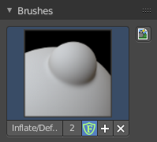
The Brush Panel contains a image browser to display the different Sculpt Brushes. Usually you have just one icon when you choose a brush from the tool shelf. But you can create your own brushes, based at the current chosen brush type. They save with the blend file when fake user is ticked.

Browse Brush
The big image at the top is a dropdown box where you can see the currently active brush. The file browser just shows the current active brush. Which gets chosen in the 3d view in the tool shelf. You can duplicate this brush, and modify it to your needs.
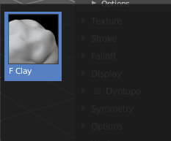
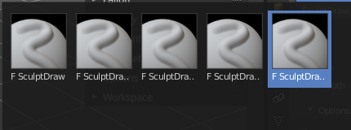
When you have added a few more brushes then the dropdown box may be more than full. You will see some little white arrows then. Either in the top left or in the bottom right corner. They indicate that some brushes are hidden before or after the current display.
To scroll to this hidden content use the mouse wheel, or the arrow up and down buttons at the keyboard.

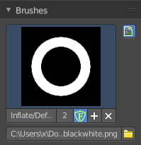
Custom Icon
The button at the right allows you to load a custom icon for your brush. It reveals a file browser below the image browser.

The edit box below the Image shows you the name of the current active brush.
The number right of it, in this case 2, indicates how much number of users ( internally ) this brush uses. This means that this data block (the brush) shares currently settings with at least one other object. Most probably the parent brush where we have created it from. Click at the value to make this brush a single user. The button will vanish then.
F set the brush to have a fake user. Zero user data-blocks are normally not saved. But sometimes you want to force the data to be kept even when the data block has no user.
The + button allows you to add a new pencil with the current settings. Note that the brushes are NOT saved when you close Bforartists. You can save them into the current blend file. Or you can save the startup file. But be careful here. This saves everything else of the current state of Bforartists too.
The X button deletes the brush as the active one. It does NOT delete it from the brushes list.

Brush Settings Panel
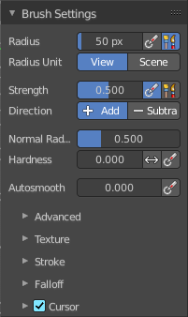
The Brush Settings Panel contains the Brush settings. The content differs, dependant of which brush you have chosen.

Brush Settings Panel - Common Settings

These settings can be found in all brushes.

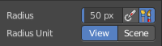
Radius
The Radius edit box allows you to adjust the radius of the brush.

Size Pressure
The first button behind the edit box enables tablet pressure sensitivity for radius.

Use Unified Radius
The second button behind the edit box enables global radius size. Any modification at the radius will also modify the radius value for other paint tools.

Radius Unit
Display the radius value in view units or in scene units. View units are by default in pixels, scene units in meters.

Strength
The Strength edit box allows you to adjust the strength of the brush.

Size Pressure
The first button behind the edit box enables tablet pressure sensitivity for radius.

Use Unified Radius
The second button behind the edit box enables global radius size. Any modification at the radius will also modify the radius value for other paint tools.

Normal Radius
The ratio between the brush radius and the radius that is going to be used to sample the normal.

Hardness
How close the brush fallow starts from the edge of the brush.

Invert Pressure for Hardness
Invert the modulation of pressure in hardness.

Use pressure for hardness
Tablet feature. Use pressure to modulate hardness.

Autosmooth
The autosmooth edit box allows you to adjust the amout of smoothing that gets automatically applied to each stroke.

Use pressure for hardness
Tablet feature. Use pressure to modulate hardness.

Brush Settings Panel - Draw brush
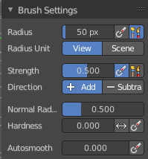

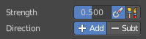
Direction Add / Subtract
Add means the stroke adds to the geometry. Subtract means the stroke subtracts from the geometry.

Brush Settings Panel - Draw Sharp brush

Direction Add / Subtract
Add means the stroke adds to the geometry. Subtract means the stroke subtracts from the geometry.

Brush Settings Panel - Clay brush
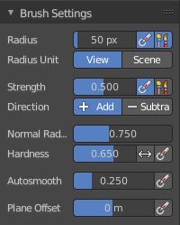

Direction Add / Subtract
Add means the stroke adds to the geometry. Subtract means the stroke subtracts from the geometry.

Plane Offset
Adjust the plane on which the brush acts towards or away from the objects surface. Sculpting with the Clay brush happens in a plane defined by the view you are in and the first vertices hit by the brush.

Brush Settings Panel - Clay Strip brush
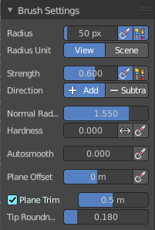

Direction Add / Subtract
Add means the stroke adds to the geometry. Subtract means the stroke subtracts from the geometry.

Plane Offset
Adjust the plane on which the brush acts towards or away from the objects surface. Sculpting with the Clay brush happens in a plane defined by the view you are in and the first vertices hit by the brush.

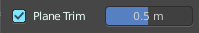
Plane Trim
Various brushes like Clay, Clay Thumb, Fill and Scrape brush. Enable Plane Trim. Sculpting with these brushes happens in a plane defined by the view you are in and the first vertices hit by the brush. The trim distance defines a limit above which vertices are not affected by the brush.

Distance
Adjust the plane trim distance.

Tip roundness
Roundness of the brush tip.

Brush Settings Panel - Clay Thumb brush
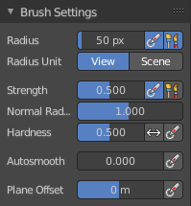

Direction Add / Subtract
Add means the stroke adds to the geometry. Subtract means the stroke subtracts from the geometry.

Plane Offset
Adjust the plane on which the brush acts towards or away from the objects surface. Sculpting with the Clay brush happens in a plane defined by the view you are in and the first vertices hit by the brush.

Plane Trim
Various brushes like Clay, Clay Thumb, Fill and Scrape brush. Enable Plane Trim. Sculpting with these brushes happens in a plane defined by the view you are in and the first vertices hit by the brush. The trim distance defines a limit above which vertices are not affected by the brush.

Distance
Adjust the plane trim distance.

Brush Settings Panel - Layer brush
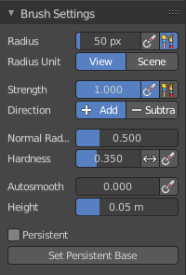

Direction Add / Subtract
Add means the stroke adds to the geometry. Subtract means the stroke subtracts from the geometry.

Height
Layer brush setting. The height that can be affected by the layer brush.

Persistent
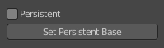
Layer brush setting. Sculpt on a persistent layer of the mesh.

Set Persistent Base
This button resets the base so that you can add another layer.

Brush Settings Panel - Inflate brush
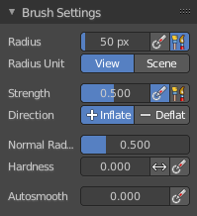

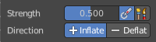
Direction Inflate / Deflate
Add or subtract effect of the brush.

Brush Settings Panel - Blob brush
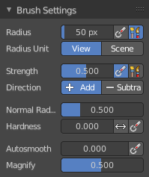

Direction Add / Subtract
Add means the stroke adds to the geometry. Subtract means the stroke subtracts from the geometry.

Magnify
The Crease Brush Pinch Factor.

Brush Settings Panel - Crease brush
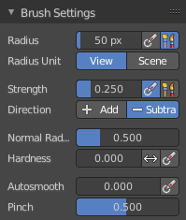

Direction Add / Subtract
Add means the stroke adds to the geometry. Subtract means the stroke subtracts from the geometry.

Pinch
The Crease Brush Pinch Factor.

Brush Settings Panel - Smooth brush
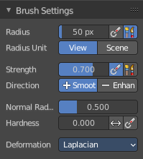

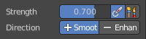
Direction Smooth / Enhance
Smooth or enhance the surface detail.

Brush Settings Panel - Flatten brush
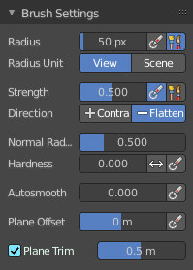

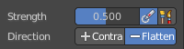
Direction Contrast / Flatten
Give more contrast or smooth the surface.

Plane Offset
Adjust the plane on which the brush acts towards or away from the objects surface. Sculpting with the Clay brush happens in a plane defined by the view you are in and the first vertices hit by the brush.

Plane Trim
Enable Plane Trim. Sculpting with these brushes happens in a plane defined by the view you are in and the first vertices hit by the brush. The trim distance defines a limit above which vertices are not affected by the brush.

Brush Settings Panel - Fill brush
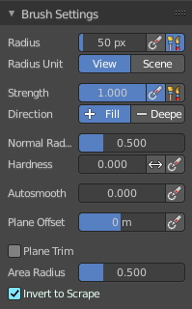

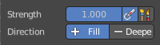
Direction Fill / Deepen
Add or subtract effect of the brush

Plane Offset
Adjust the plane on which the brush acts towards or away from the objects surface. Sculpting with the Clay brush happens in a plane defined by the view you are in and the first vertices hit by the brush.

Plane Trim
Enable Plane Trim. Sculpting with these brushes happens in a plane defined by the view you are in and the first vertices hit by the brush. The trim distance defines a limit above which vertices are not affected by the brush.

Area Radius
The ratio between the brush radius and the radius that is going to be used to sample the area center.

Invert to Scrape
Invert the stroke to a scrape stroke. Does not invert the displacement direction.

Brush Settings Panel - Fill brush
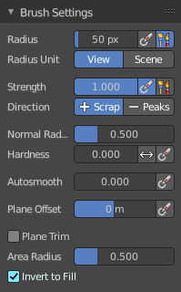

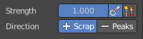
Direction Scrape / Peaks
Add or subtract effect of the brush.

Plane Offset
Adjust the plane on which the brush acts towards or away from the objects surface. Sculpting with the Clay brush happens in a plane defined by the view you are in and the first vertices hit by the brush.

Plane Trim
Enable Plane Trim. Sculpting with these brushes happens in a plane defined by the view you are in and the first vertices hit by the brush. The trim distance defines a limit above which vertices are not affected by the brush.

Area Radius
The ratio between the brush radius and the radius that is going to be used to sample the area center.

Invert to Fill
Use scrape or fill tool when inverting this brush instead of inverting its displacement direction.

Brush Settings Panel - Multi-plane Scrape brush
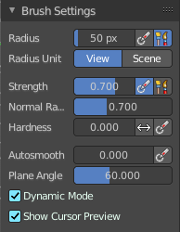

Direction Scrape / Peaks
Add or subtract effect of the brush.

Plane Angle
Multiplane Scrape brush. The angles between the planes of the crease.

Dynamic Mode
Multiplane Scrape brush. Fit the angles during the stroke to fit the angles under the cursor.

Show Cursor Preview
Multiplane Scrape brush. Preview the plane scrapes in the cursor during the stroke.

Brush Settings Panel - Pinch brush
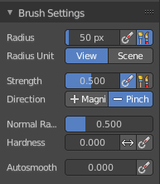

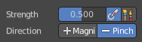
Direction Magnify / Pinch
Add or subtract effect of the brush.

Autosmooth
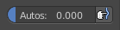
The autosmooth edit box allows you to adjust the amout of smoothing that gets automatically applied to each stroke. The button behind the edit box enables tablet pressure sensitivity for autosmooth.

Brush Settings Panel - Grab brush
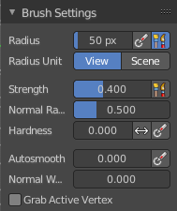

Direction Magnify / Pinch
Add or subtract effect of the brush.

Normal Weight
How much grab will pull vertexes out of surface during grab.

Grab active Vertex
Apply the maximum grab strength to the active vertex instead of the cursor position.

Brush Settings Panel - Elastic Deform brush
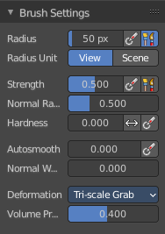

Direction Magnify / Pinch
Add or subtract effect of the brush.

Normal Weight
How much grab will pull vertexes out of surface during grab.

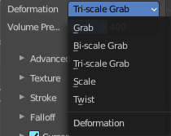
Deformation
The deformation type to use.

Volume Preservation
Poisson ratio for elastic deform. The higher the value is the more the volume is kept. But leads to more bulging.

Brush Settings Panel - Snake Hook brush
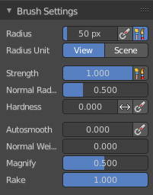

Normal Weight
How much grab will pull vertexes out of surface during grab.

Magnify
The Crease Brush Pinch Factor.

Rake
How much grab will follow cursor rotation.

Brush Settings Panel - Thumb brush
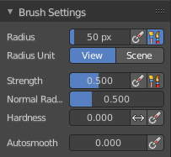
Just standard settings.

Brush Settings Panel - Pose brush

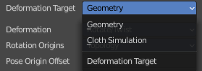
Deformation Target
Pose Brush setting. How the deformation of the brush will affect the object.

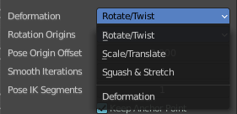
Deformation
Pose Brush setting. Deformation type that is used in the brush.

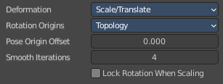
Lock Rotation when scaling
With Scale/Translate mode. Do not rotate the segment when using the scale deform mode.

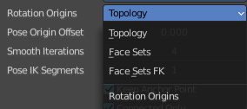
Rotation Origins
Pose Brush setting. Define the rotation origins.

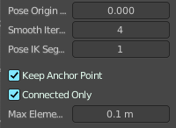
Pose Origin Offset
Pose Brush setting. Offset of the pose origin in relation to the brush radius.

Smooth Iterations
Pose Brush setting. Smooth iterations applied after calculating the pose factor of each vertex.

Pose IK Segments
Pose Brush setting. Number of segments of the IK chain that will deform the mesh.

Keep Anchor Point
Pose Brush setting. Keep the position of the last segment in the IK chain fixed.

Connected only
Affect only topology connected elements.

Max Element Dinstance
Maximum distance to search for disconnected loose parts in the mesh.

Brush Settings Panel - Nudge brush
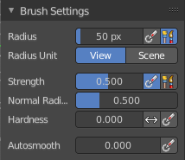
Just standard settings.

Brush Settings Panel - Rotate brush
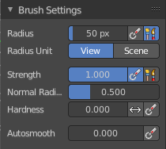

Brush Settings Panel - Slide Relax brush
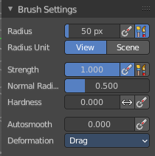

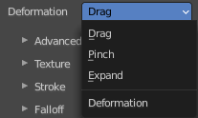
Deformation
The deformation type to use.

Brush Settings Panel - Boundary brush
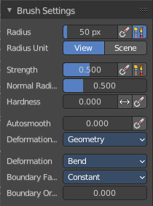

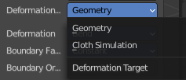
Deformation Target
The deformation type to use.

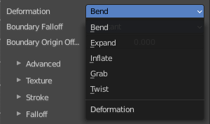
Deformation
The deformation type to use.

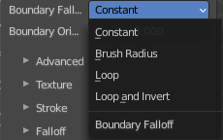
Boundary Falloff
Boundary brush option. The falloff type.

Boundary Origin Offset
Boundary brush option. Offset of the boundary origin in relation to the brush radius.

Brush Settings Panel - Cloth brush
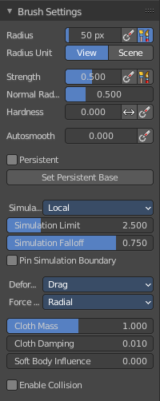

Persistent
Layer brush setting. Sculpt on a persistent layer of the mesh.

Set Persistent Base
This button resets the base so that you can add another layer.

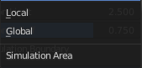
Simulation Area
Cloth brush. Simulates either only a specific area around the brush or the entire mesh.

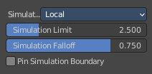
Simulation Limit
Cloth brush with local area. Factor added relative to the size of the radius. To limit the cloth simulation effect.

Simulation Falloff
Cloth brush with local area. The area to apply deformation falloff to the effects of the simulation.

Pin Simulation Boundary
Lock the position of the vertices in the simulation falloff area.

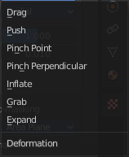
Deformation
Cloth brush. The type of cloth deformation that you want to perform.

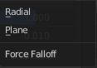
Force Falloff
Cloth brush. The shape that is used in the brush to apply force to the cloth.

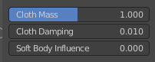
Cloth Mass
Cloth brush. The mass of each simulation particle.

Cloth Damping
Cloth brush. How much the applied forces are propagated through the cloth.

Soft Body Influence
Cloth brush. How much the simulation preserves the original shape, acting as a soft body.

Enable Collision
Cloth brush. Collide with objects during the simulation.

Brush Settings Panel - Simplify brush
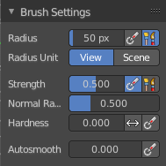
Just standard settings.

Brush Settings Panel - Mask brush
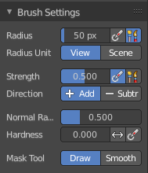

Direction Add / Subtract
Add means the stroke adds to the geometry. Subtract means the stroke subtracts from the geometry.

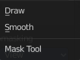
Mask Tool
Draw or smooth the current mask.

Brush Settings Panel - Multires Displacement Eraser brush
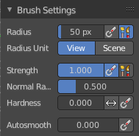
Just standard settings.

Brush Settings Panel - Draw Face Sets brush
Just standard settings.

Brush Settings Panel - Advanced Subpanel
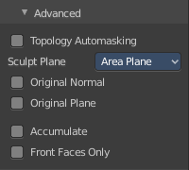
In this subpanel you can find the not so often used settings. They differ from brush to brush. Have a look at the tooltips.

Topology Automasking
Affect only vertices that are connected to the current active vertex under the brush.

Face Sets Auto-masking
Affect only vertices that share face sets with the active vertex.

Accumulate
Accumulate stroke daubts on top of each other.

Sculpt Plane
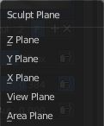
The sculpt plane defines how the sculpting is aligned. It is a dropdown box wChoose different methods. By default the Area Plane gets used.

Original Normal
When ticked keep using normal of the surface where the stroke was initiated.

Original Plane
When ticked keep using plane origin of the surface where the stroke was initiated.

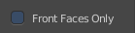
Front Faces Only
Front Faces only means that the stroke just affects the vertices that are pointing forwards to the camera.

Brush Settings Panel - Texture Subpanel
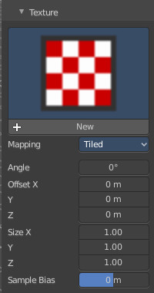
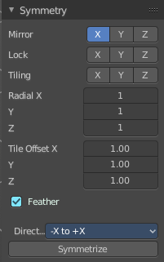
The Texture panel allows you to sculpt with textures. This allows you for example to grab a foto from some fish scales, and simply sculpt them into the surface of your object by using this image as a pencil. Or as a blueprint where you calk through ( Stencil method ).

Note that the following shots are made with Symmetry off and without Brush falloff. Since they disturbed.

Symmetry can be turned off a few panels deeper in the Symmetry panel

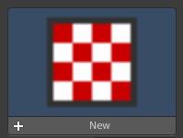
Browse Texture to be linked
The image at the top of the panel is a image browser. Choose a texture that you can choose for sculpting then. You can also have more than one image loaded at once.

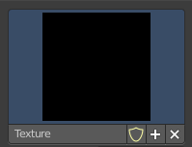
Adding a texture

The way to add the texture here is a bit more complicated. And not done with clicking at the New button.

First click at the New button below the image. This will create a new texture slot. This slot is still empty, it displays black.

We need to load the texture in this slot. This must be done in the Properties editor in the Textures tab.
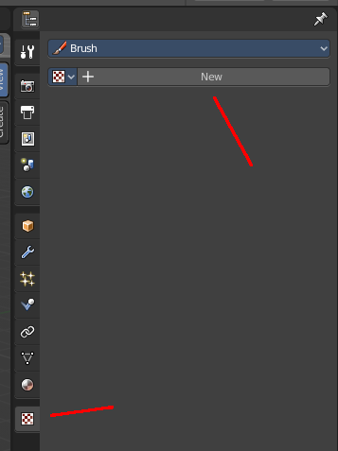
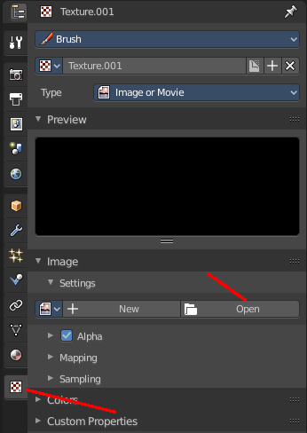
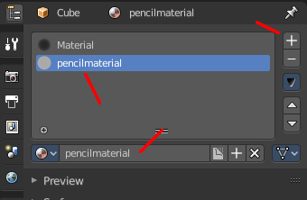
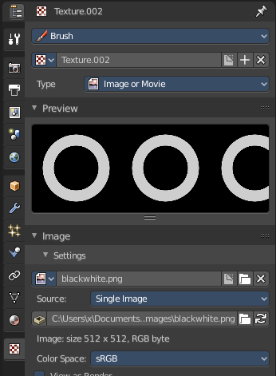

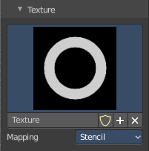
And when you switch back to the Tools tab, then the texture finally shows in the Texture panel in the Tool Shelf. And we can use it.

Texture Edit box
The Texture edit box is the edit box below the Image browser. When there's no image loaded then it displays the New button. When there's a image (or more) loaded, then you will see the name of the current texture.
The Fake User button turns this texture into a data block with a fake user. Means it will exists even when there is no data connected to it anymore.
The + Button adds another texture slot. Note that you will have to load a texture too, as explained above.
The X button deletes the texture slot.

Brush Mapping
Our texture can be mapped in different methods. The Brush mapping is a dropdown box wChoose this different brush mapping methods.
The settings vary. So we will go through them by the different brush mapping methods.

Brush Mapping with mapping method View Plane and Area Plane
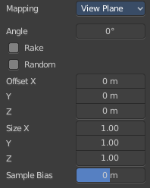
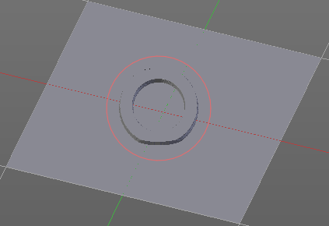
The brush mapping method View Plane maps the brush onto the surface of the object, calculating the mapping from the current view. The result may be distorted when the view does not align with the surface of the object.
The brush mapping method Area Plane maps the brush onto the surface of the object, calculating the mapping from the current view. The result is not distorted.

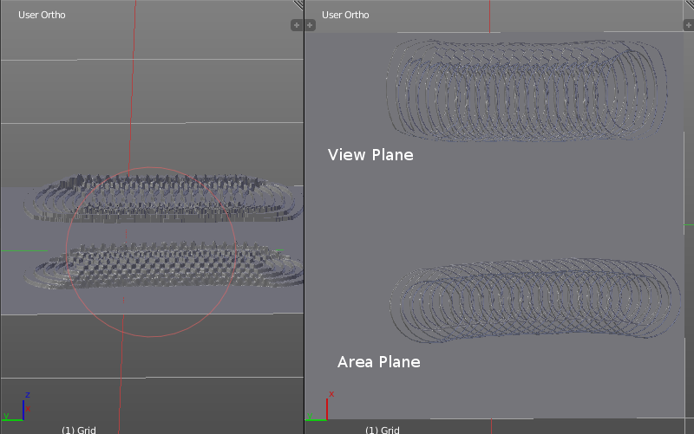
Angle edit box
Adjust the angle of the brush.

Rake
The angle follows the direction of the brush stroke.

Random
The brush angle gets set random.

Random edit box
Becomes visible when you tick Random. Adjust the maximum value of the random angle.

Offset
Fine tune the offset of the texture in the brush.

Size
Fine tune the size of the texture in the brush.

Sample Bias
Add to or subtract from the amount that gets added by the brush texture.

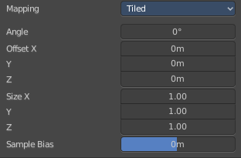
Brush Mapping with mapping method Tiled
The brush mapping method View Plane maps the brush onto the surface of the object, and tiles the pencil onto the surface. The mapping happens from the View plane. Means you get distortions when you sculpt from an angle.
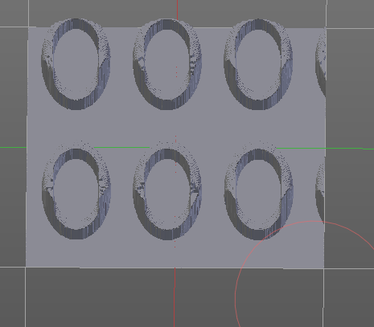

Angle edit box
Adjust the angle of the brush.

Offset
Fine tune the offset of the texture in the brush.

Size
Fine tune the size of the texture in the brush.

Sample Bias
Add to or subtract from the amount that gets added by the brush texture.

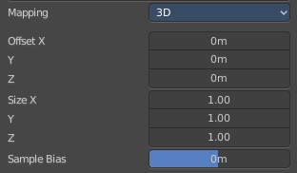
Brush Mapping with mapping method 3D
The brush mapping method View Plane and Area Plane sculpts where the pencil is. The method 3D sculpts at the initial position of the pencil, as long as you don't release the mouse. The mapping happens from the View plane. Means you get distortions when you sculpt from an angle.

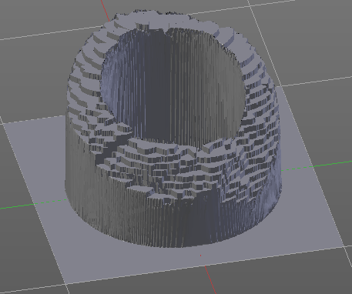
Offset
Fine tune the offset of the texture in the brush.

Size
Fine tune the size of the texture in the brush.

Sample Bias
Add to or subtract from the amount that gets added by the brush texture.

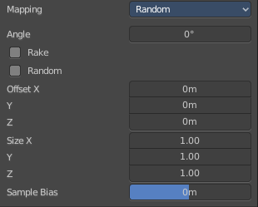
Brush Mapping with mapping method Random
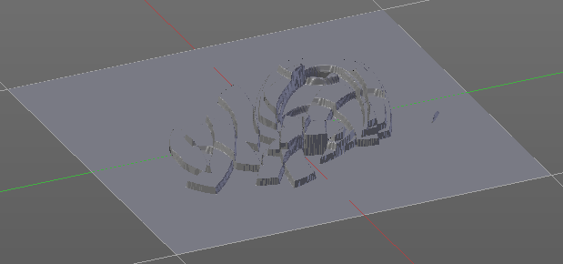
The brush mapping method Random randomizes the texture position of the pencil texture. And so it sculpts random fragments of the pencil.

Angle edit box
Adjust the angle of the brush.

Rake
The angle follows the direction of the brush stroke.

Random
The brush angle gets set random.

Random edit box
Becomes visible when you tick Random. Adjust the maximum value of the random angle.

Offset
Fine tune the offset of the texture in the brush.

Size
Fine tune the size of the texture in the brush.

Sample Bias
Add to or subtract from the amount that gets added by the brush texture.

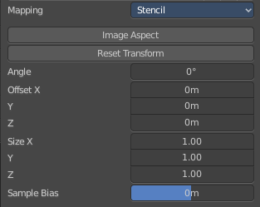
Brush Mapping with mapping method Stencil
The former methods uses the textures for the brush. The method Stencil works different. You have your texture displayed in the workspace above the object, and you paint this texture onto your object with your pencil strokes.
Note that the texture in the 3d space is just visible when you are with the mouse over the viewport.
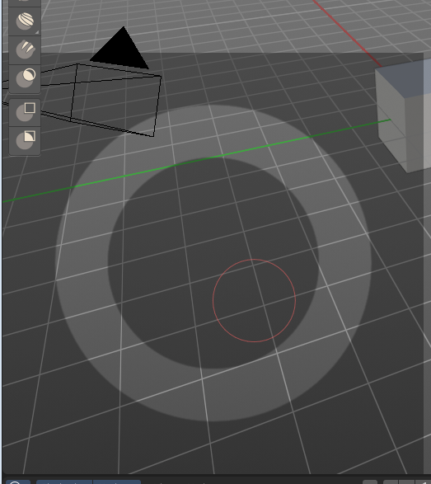

Image Aspect
Adjust the stencil size to fit to the image aspect ratio.

Angle edit box
Adjust the angle of the brush. The button at the end allows you to set the radius by dragging the mouse. This should be done in the viewport and with the hotkey. This button is just a visible reminder.

Offset
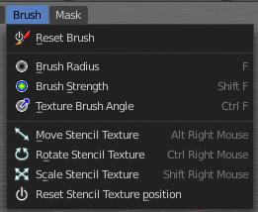
Fine tune the offset of the texture in the brush.

Stencil Texture Controls
You can find the controls to modify the position, rotation and scale of the stencil texture in the Brush menu in the 3D view. This happens by Hotkeys.

Brush Settings Panel - Stroke Subpanel
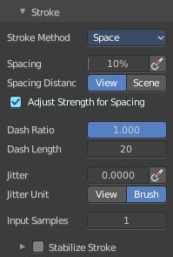
The Stroke panel contains settings to influence the behaviour of the brush stroke. There are various stroke methods available. We will go through them one by one.

Stroke Panel with Stroke method Space
This is the default Stroke method. The sculpt stroke gets added continuously with given settings.
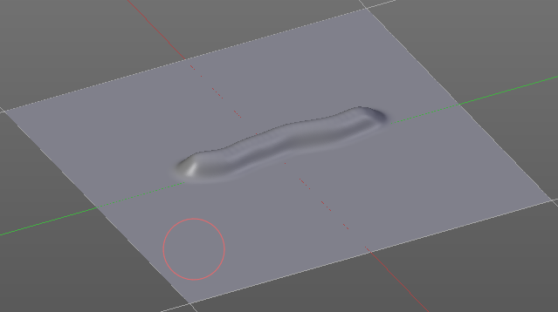

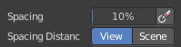
Spacing Edit Box
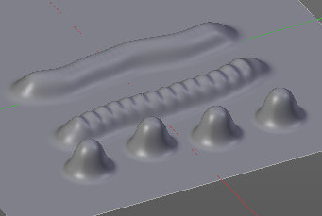
The sculpt drawing happens by mapping the pencil onto the mouse position. And when you move the mouse then the next mapping happens. Adjust the spacing after what mouse movement the next mapping should happen. The lower the value, the lower the distance between the single dots.

Spacing Pressure
The icon behind the edit box enables tablet pressure sensitivity for tablets.

Spacing Distance
If the spacing happens in View or in Scene distance.

Adjust Strength for Spacing
Automatically adjust the strength to give consistent results for different spacings.

Dash Ratio
Ratio of samples in a cycle that the brush is enabled.

Dash Length
Length of a dash cycle measured in stroke samples.

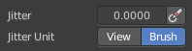
Jitter Edit Box
Add Jitter to the brush while painting.

Jitter Pressure
The icon behind the edit box enables tablet pressure sensitivity for tablets.

Jitter Unit
If the jitter happens in screen space in pixels, or relative to the brush size.

Input Samples Edit Box
Average multiple input samples together to smooth the brush stroke.

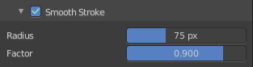
Stabilize Stroke
When activated then the brush lags behind the mouse position, and produces a much smoother stroke by that. It is a subpanel with two settings.

Smooth Stroke Radius Edit Box
Adjust the radius of the smoothing.

Smooth Stroke Factor Edit Box
Adjust the factor of the smoothing.

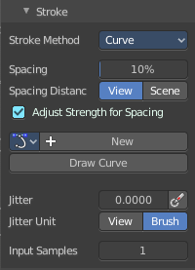
Stroke Panel with Stroke method Curve
The Stroke method curve doesn't simply influence the way how the stroke is painted.
It is a special method. First you draw a curve object by holding down ctrl and clicking with left mouse button. Then you tweak the curve. You can click at the curve point, and drag out handlers to make the curve points smoooth.
Then you hit the Draw Curve button. And the curve gets sculpted.

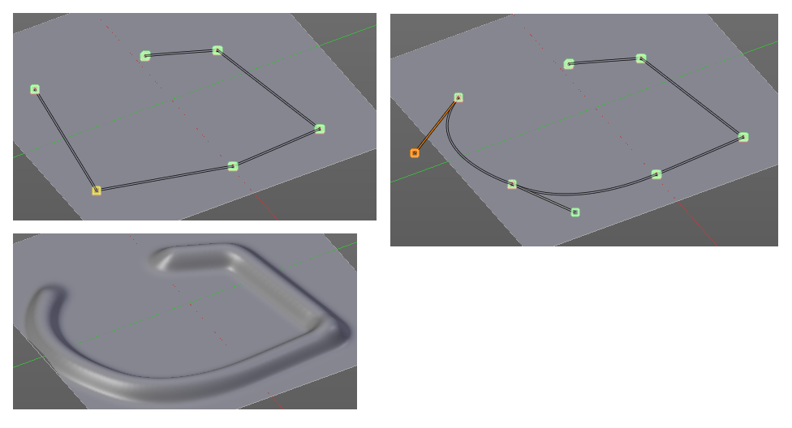

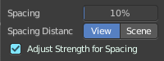
Spacing Edit Box
The sculpt drawing happens by mapping the pencil onto the mouse position. And when you move the mouse then the next mapping happens. Adjust the spacing after what mouse movement the next mapping should happen. The lower the value, the lower the distance between the single dots.
The icon behind the edit box enables tablet pressure sensitivity for tablets.

Spacing Distance
If the spacing happens in View or in Scene distance.

Adjust Strength for Spacing
Automatically adjust the strength to give consistent results for different spacings.

Paint Curve edit box
Here you set the active curve.
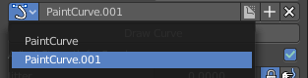
The first element is a dropdown box where you will find your curves objects. You can have more than one.
The second element is the edit box that displays the active curve.
Fake User set the brush to have a fake user. Zero user data-blocks are normally not saved. But sometimes you want to force the data to be kept even when the data block has no user.
The + button allows you to add a new pencil with the current settings. Note that the brushes are NOT saved when you close Bforartists. You can save them into the current blend file. Or you can save the startup file. But be careful here. This saves everything else of the current state of Bforartists too.
The X button deletes the brush as the active one. It does NOT delete it from the brushes list.

Draw Curve Button
A click at it to turns the curve into a sculpt stroke.

Jitter Edit Box
Add Jitter to the brush while painting.

Jitter Pressure
The icon behind the edit box enables tablet pressure sensitivity for tablets.

Jitter Unit
If the jitter happens in screen space in pixels, or relative to the brush size.

Input Samples Edit Box
Average multiple input samples together to smooth the brush stroke.

Stroke Panel with Stroke method Line
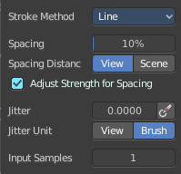
With Stroke method line you draw a line between a starting point and a endpoint. And when you release the mouse then the line gets sculpted.

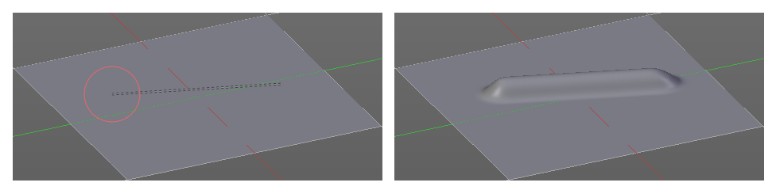

Spacing Edit Box
The sculpt drawing happens by mapping the pencil onto the mouse position. And when you move the mouse then the next mapping happens. Adjust the spacing after what mouse movement the next mapping should happen. The lower the value, the lower the distance between the single dots.
The icon behind the edit box enables tablet pressure sensitivity for tablets.

Spacing Distance
If the spacing happens in View or in Scene distance.

Adjust Strength for Spacing
Automatically adjust the strength to give consistent results for different spacings.

Jitter Edit Box
Add Jitter to the brush while painting.

Jitter Pressure
The icon behind the edit box enables tablet pressure sensitivity for tablets.

Jitter Unit
If the jitter happens in screen space in pixels, or relative to the brush size.

Input Samples Edit Box
Average multiple input samples together to smooth the brush stroke.

Stroke Panel with Stroke method Airbrush
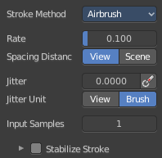
The sculpt stroke acts like an airbrush pencil. The dots gets placed randomly.
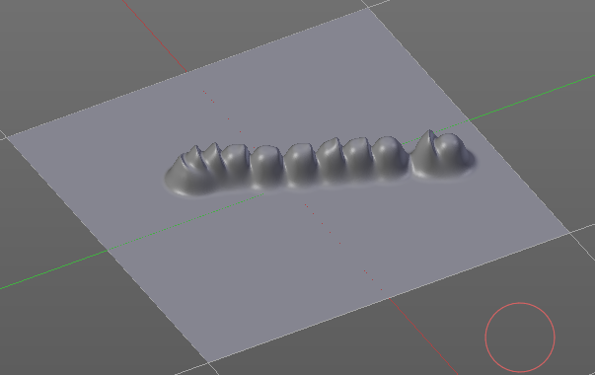

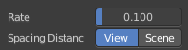
Rate Edit Box
Define the rate of the drawing.

Spacing Distance
If the spacing happens in View or in Scene distance.

Jitter Edit Box
Add Jitter to the brush while painting.

Jitter Pressure
The icon behind the edit box enables tablet pressure sensitivity for tablets.

Jitter Unit
If the jitter happens in screen space in pixels, or relative to the brush size.

Input Samples Edit Box
Average multiple input samples together to smooth the brush stroke.

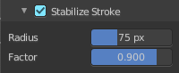
Stabilize Stroke
When activated then the brush lags behind the mouse position, and produces a much smoother stroke by that. Smooth stroke has two settings.

Smooth Stroke Radius Edit Box
Adjust the radius of the smoothing.

Smooth Stroke Factor Edit Box
Is just active when Smooth Stroke is activated. Adjust the factor of the smoothing.

Stroke Panel with Stroke method Anchored
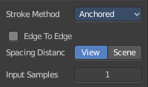
Click and drag to place a dot and to scale it.

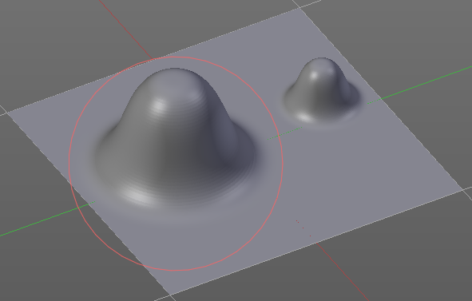

Edge to Edge
Without Edge to Edge the scaling happens from the center of the brush. With edge to edge the scaling happesn from the edge of the brush.

Spacing Distance
If the spacing happens in View or in Scene distance.

Input Samples Edit Box
Average multiple input samples together to smooth the brush stroke.

Stroke Panel with Stroke method Drag dot
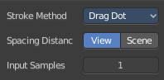
Click and drag to place a dot.

Spacing Distance
If the spacing happens in View or in Scene distance.
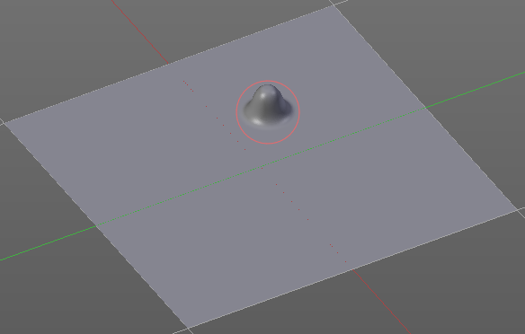

Input Samples Edit Box
Average multiple input samples together to smooth the brush stroke.

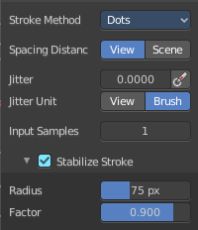
Stroke Panel with Stroke method dot
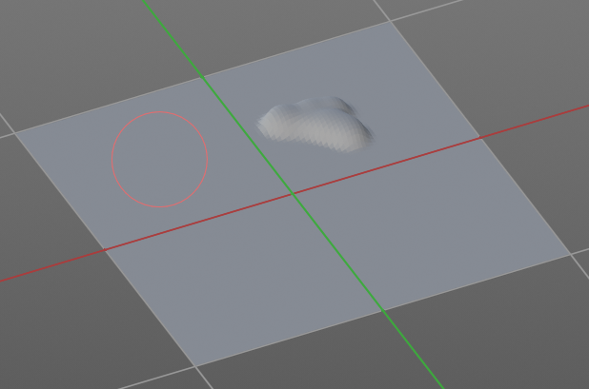

Spacing Distance
If the spacing happens in View or in Scene distance.

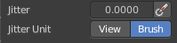
Jitter Edit Box
Add Jitter to the brush while painting.
The icon behind the edit box enables tablet pressure sensitivity for tablets.

Jitter Unit
Jitter in screen space or relative to the brush size.

Input Samples Edit Box
Average multiple input samples together to smooth the brush stroke.

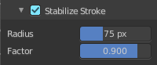
Stabilize Stroke
When activated then the brush lags behind the mouse position, and produces a much smoother stroke by that. Smooth stroke has two settings.

Smooth Stroke Radius Edit Box
Adjust the radius of the smoothing.

Smooth Stroke Factor Edit Box
Adjust the factor of the smoothing.

Brush Settings Panel - Falloff Subpanel
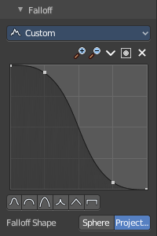
The Falloff panel allows you to define different fallofs methods for the border of the brush.


Selecting Points
You can select curve points. This reveals two edit boxes for the x and y coordinate of this point.
Selected points can be moved around. Left click at them, hold the mouse button down and move them to a new location.


Adding Points
You can add new curve points by simply left clicking at the curve. Move the mouse to position them where you need it.

Navigation elements
The navigation elements at the top are described from left to right.

Zoom in and out
The two buttons with the magnifying glass at it zooms in and out in the curve window.

Tools
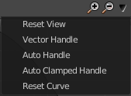
Tools is a menu where you can find some cuve related tools.

Reset View
Resets the curve windows zoom.

Vector Handle
Set handle type to Vector.

Auto Handle
Set handle type to Auto.

Auto Clamped Handle
Set handle type to Auto Clamped.

Reset Curve
Resets the curve to the initial shape.


Use Clipping
Clipping options. Set up clipping for the stroke. The blue button at the top turns clipping on or off.

Delete Points
Deletes the selected curve point.


Curve Presets
Predefined curve presets.

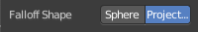
Falloff Shape
Use projected or spherical falloff.

Brush Settings Panel - Cursor Subpanel
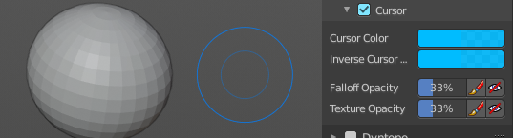
Change the appearance of the brush cursor.

Cursor checkbox in header
Show or hide the brush cursor.

Cursor Color
The cursor color with add operations.

Inverse Cursor Color
The cursor color with subtract operations.

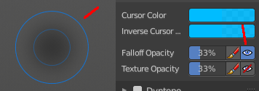
Falloff Opacity
You can turn on the cursor overlay with the eye button at the end. The falloff opacity slider allows you to adjust the opacity of this cursor overlay.

Override Overlay
Hide the Cursor Overlay when painting.

Use Cursor Overlay
Turn on Cursor Overlay.

Texture Opacity
This is for the case when you paint with a texture brush. You can turn on the Texture overlay with the eye button at the end. The falloff opacity slider allows you to adjust the opacity of this cursor overlay.

Override Overlay
Hide the Texture Overlay when painting.

Use Cursor Overlay
Turn on Texture Overlay.

Dyntopo Panel

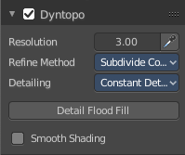
Dyntopo Panel
Dyntopo stands for Dynamic Topology Sculpting.
Without dyntopo you just deform the existing geometry. With Dyntopo geometry gets subdivided when needed. This makes it possible to sculpt complex shapes out of a block.
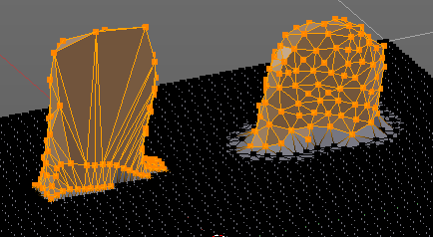
Left without Dyntopo, right with Dyntopo.
Note that some brushes does not work with Dyntopo. They are Grab brush, Rotate brush, Thumb brush, Layer brush, Smooth brush (including alt-key smoothing with a different brush) and Mask brush.
The topology will also not be updated if the stroke mode is Anchored or Drag Dot.

Resolution
The Resolution defines how fine the subdivision will be.
The edit box below does the same. But with a slider, and without visible feedback in form of a widget.

Sample detail size picker
This pipette allows you to pick the current resolution from a mesh.

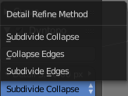
Refine method
Define the Detail refine method.

Subdivide Collapse
Both methods in one. Subdivide long edges to add mesh detail where needed. And collapse short edges to remove mesh detail where possible.

Collapse Edges
Collapse short edges to remove mesh detail where possible.

Subdivide Edges
Subdivide long edges to add mesh detail where needed.

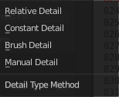
Detailing
Define the Detail Type method.

Relative Detail
Mesh Detail is relative to brush size and detail size

Brush Detail
Mesh Detail is relative to brush radius.

Constant Detail
Mesh detail is constant in object space according to detail size.

Manual Detail
Mesh detail does not change on each stroke. But just on flood fill

Smooth shading
Show faces in smooth shading instead of flat shading.

Remesh Panel

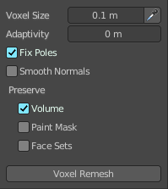
You may create a sculpt mesh that has ways too many polygons. Or too many polygons at one area, and not enough polygons at another area. Remeshing recreates the mesh geometry, with a more uniform topology.
Remesh does not work with Dyntopo enabled. You need to turn it of for remeshing.

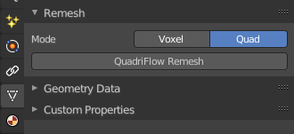
The Remesher in Sculpt mode uses the Voxel remesher only. When you want to remesh with the Quadriflow method, then use the settings in the Properties editor.

Voxel Size
Adjust the density of the new created geometry

Sample Detail Size
With this picker you can pick the density from an area of your mesh.

Adaptivity
Reduces the final face count by simplifying geometry where detail is not needed. Ths method uses tris. A value greater than 0 disables the Fix Poles feature.

Fix Poles
Produce less poles and a better topology flow.

Smooth Normals
Smoothes the normals of the result.

Preserve

Volume
Tries to preserves the volume of the original mesh.

Paint Mask
Keep existing paint masks at the newe mesh.

Face Sets
Keep the current face sets at the new created mesh.

Remesh
Starts the remesher.

Symmetry Panel
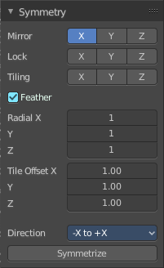
The Symmetry Lock panel contains tools around symmetry and lock features. Here you can turn on or off mirroring along axis, etc.

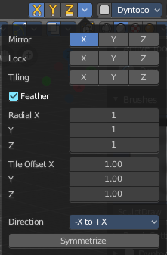
Mirror
Mirror sculpt along activated axis. By default the mirroring is activated around X axis.
The same buttons plus the whole Symmetry Lock Panel as a dropdown menu can also be found in the tool settings bar as icon buttons. This allows quicker access and better visual control which mirror axis is currently active.

Lock
Disallow vertices movement in locked axis direction.

Tiling
Produces a mesh that is tilable in the activated directions.

Feather
Reduce the strength of the brush where it overlaps symmetrical daubs.

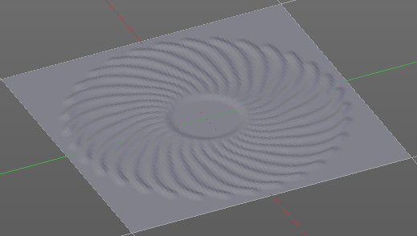
Radial
Adjust the repeatings across some axis. For example, when you change Z to 32, then you can draw 32 segments simultaneously around the Z axis instead of just one, distributed around the Z axis.

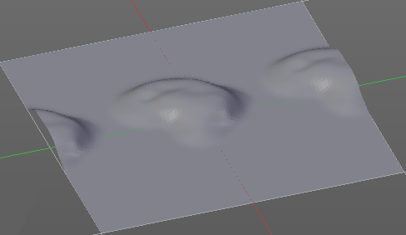
Tile Offset
Adjust the offset of the tiling.

Direction
The direction in which the mirroring happens.

Symmetrize
Symmetrize the topology modifications.

Sculpt Mode - Options Panel

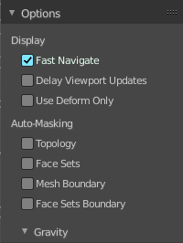
Display

Fast Navigate
For Multires, show Low Res mesh when navigating.

Delay Viewport Updates
Update the geometry when it enters the view. This enables a faster viewport navigation.

Use Deform only
Use only deformation modifiers ( The other constructive modifiers except multi-resolution gets temporary disabled)

Auto Masking

Topology
Affect only vertices connected to the active vertex under the brush.

Face Sets
Affect only vertices that share face sets with the active vertex.

Mesh Boundary
Do not affect non manifold boundary edges.

Face Sets Boundary
Do not affect vertices that belongs to a face set boundary.

Gravity subpanel
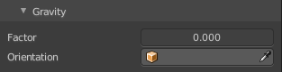
A panel with the gravity settings. Add gravity after each stroke.

Factor
The factor silder defines the amount.

Orientation
Here you define an object that gets used to determine the gravity from. The Z axis of this object gets used.

